Name _______________________________ AP Calculus

Chapter 5 Test REVIEW

Show all your work! Scientific calculator allowed. Graphing calculator not allowed.

For Review use Chapter 5 Review in Book as well as 2005AB FRQ 4 ands the following:

1. 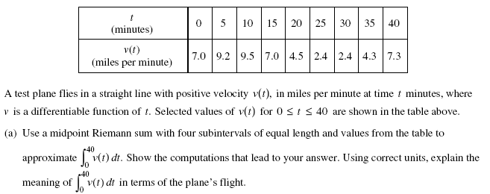

2.

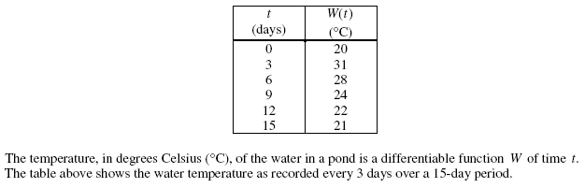



3. 4.

5. The chart below shows the time and distance a rabbit travels from t = 0 seconds to t = 5 seconds. Determine the total distance the rabbit travels in that time.

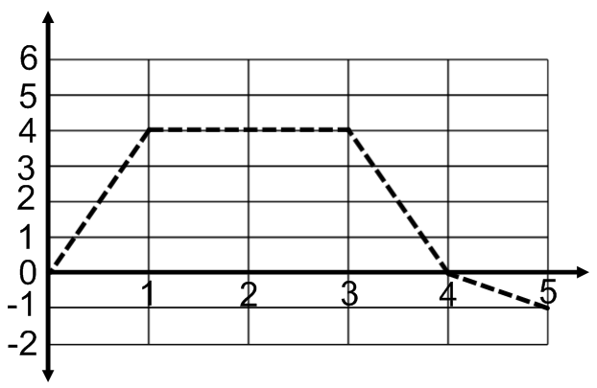

6. If , find F’(4). 7. Find the average value of -sin x from [-π, 2π]